VM Use Cases

Use Case 1: Big Data / Analytics Processing Running PySpark Word Count Program
Objective: To demonstrate how Azure Virtual Machine (VM) can be used for Big Data processing by running a PySpark WordCount program.
Tools:
- Azure Virtual Machine (VM) – Host environment for running Spark.
- Java (OpenJDK) – Required to run Apache Spark.
- Apache Spark – Big Data processing framework.
- Nano – To create input and program files.
Flow Diagram:

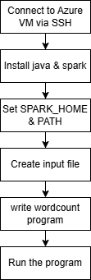

Step1: Connect to VM using SSH
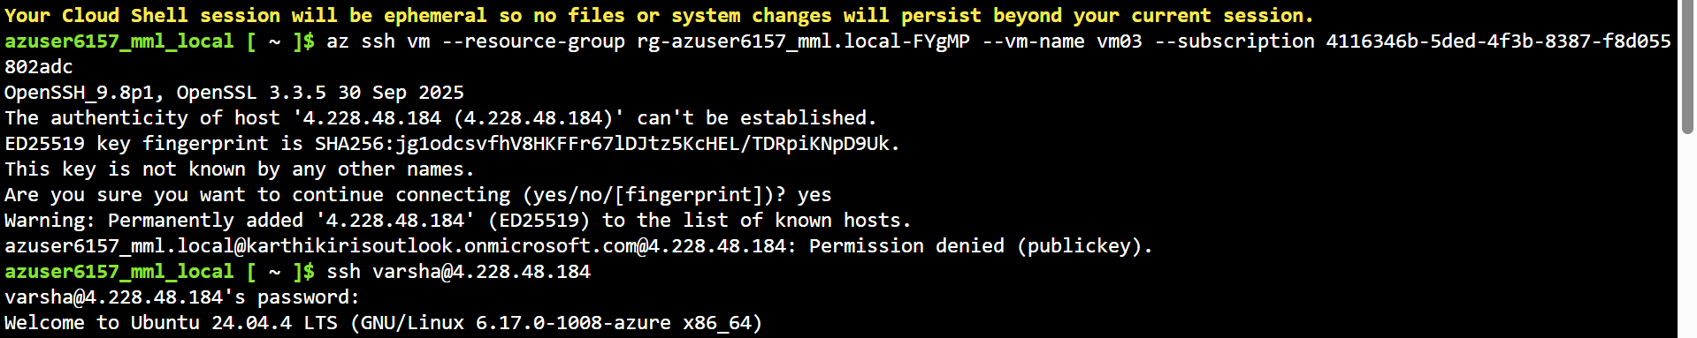
Step2: Update and install java since spark need java
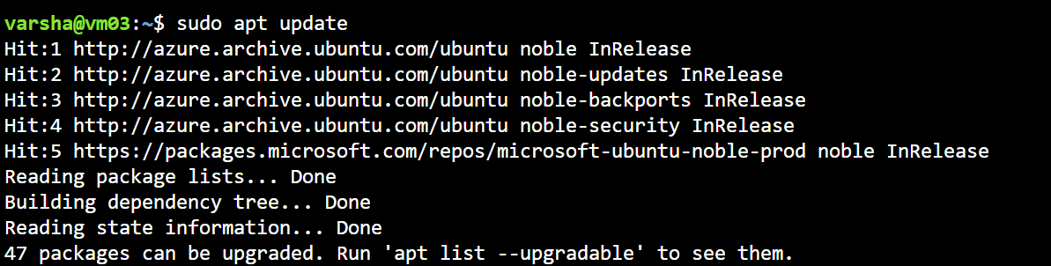
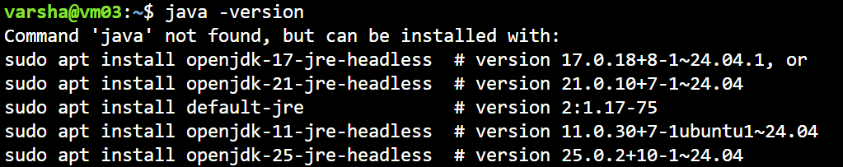
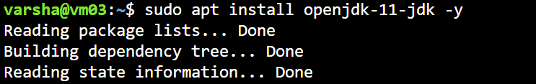
Step3: Install Spark
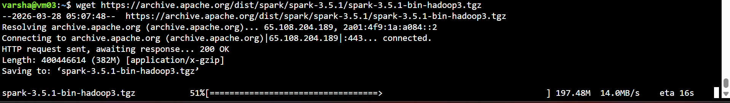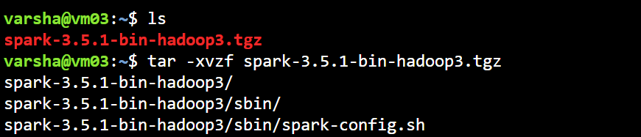
Step4: Set spark path
Set environment variables (SPARK_HOME, PATH) to make spark-submit accessible.
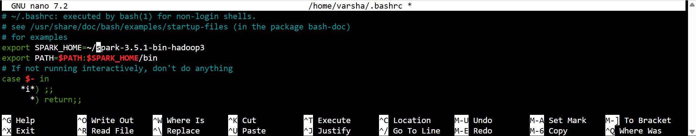
To apply changes
To verify spark installation
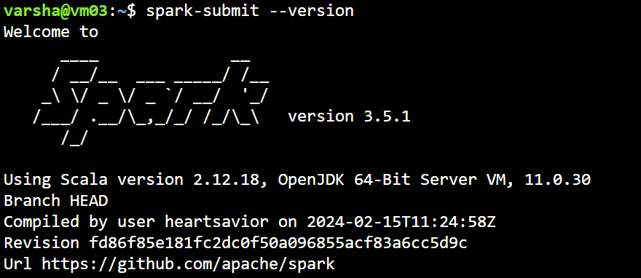
Step 6: Create input file
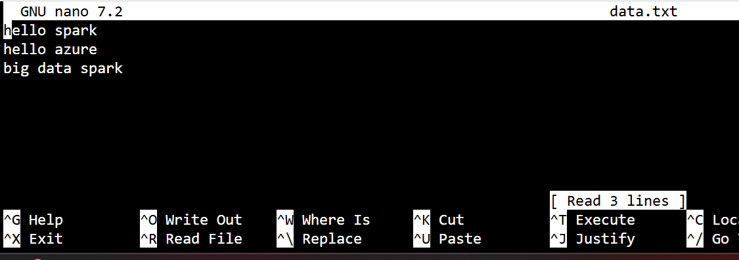

Step 7: Create spark program file
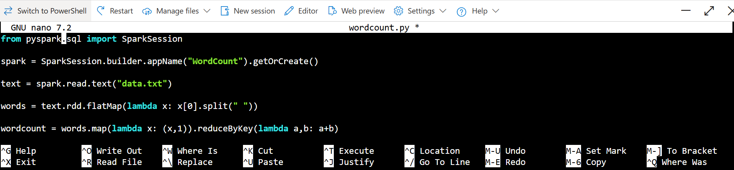

Step8: Run the program
spark-submit wordcount.py
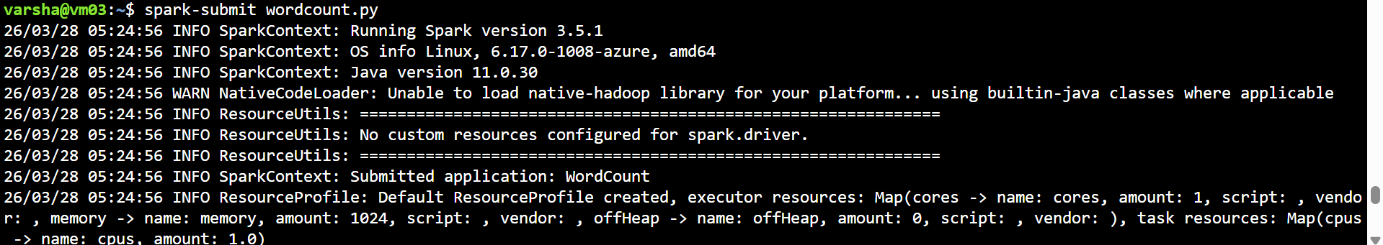
Add below line in wordcount program file to avoid logs
spark.sparkContext.setLogLevel("ERROR")
and run using
spark-submit wordcount.py 2>/dev/null
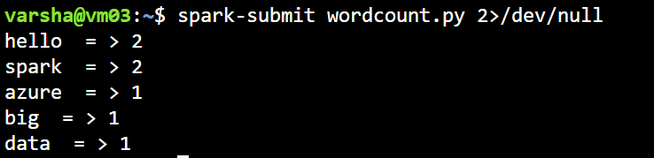

Use case 2: Host Website
Objective: Deploy a website on an Azure VM using Nginx and Git.
Tools:
- Azure VM – host server
- Nginx – web server
- Git / GitHub – version control and upload
Flow Diagram:
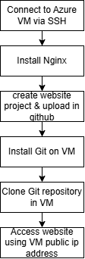
Step 1: Connect to VM using SSH

Step 2: Install nginx
sudo apt update
sudo apt install nginx -y
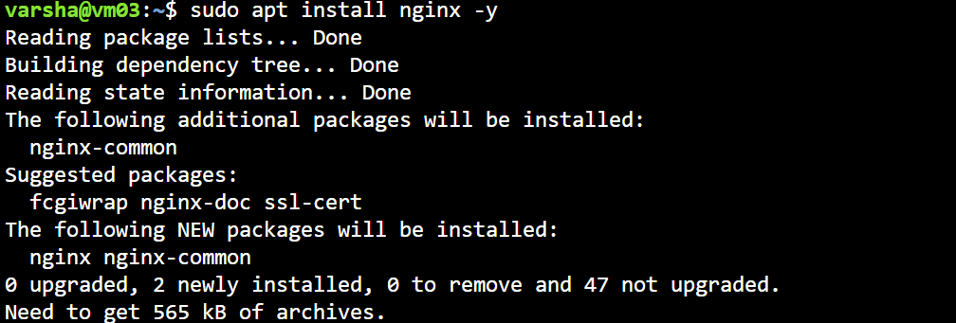
To check status:
systemctl status nginx
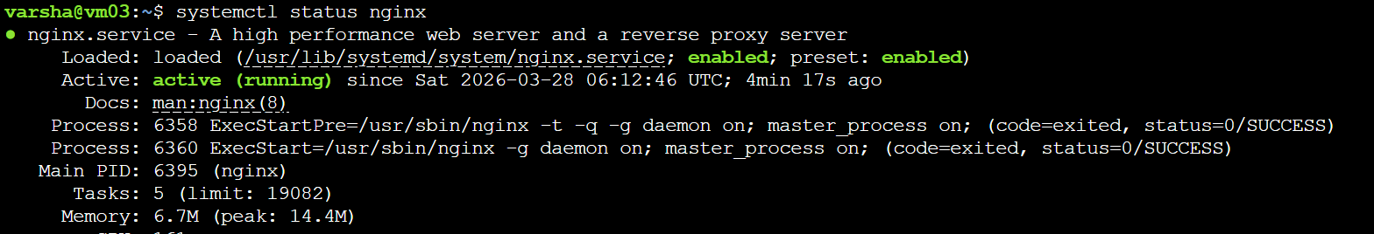
Step 3: Create project folder
Create project structure and files in vscode
then upload in git
Step 4: Install git in azure VM
sudo apt install git -y 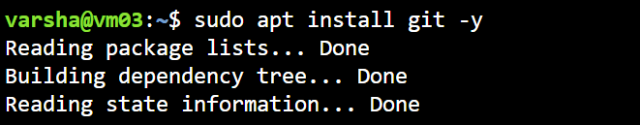
Step 5: clone git repository in vm
sudo git clone https://github.com/varsha-shaji/website.git website
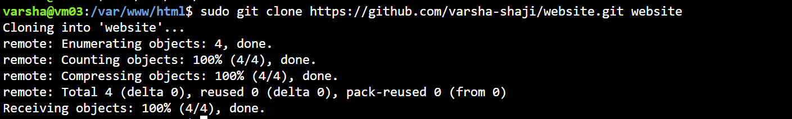

Open : http://<public-ip>/website/

Use case 3: Auto-Update Website Using Cron Job
Objective: Automatically pull the latest website changes from GitHub at regular intervals.
Tools:
- Azure VM – host server
- Cron Job – schedule task
- Git / GitHub – version control

Flow diagram:
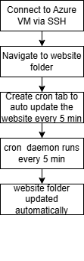

Step 1: Connect to VM using SSH
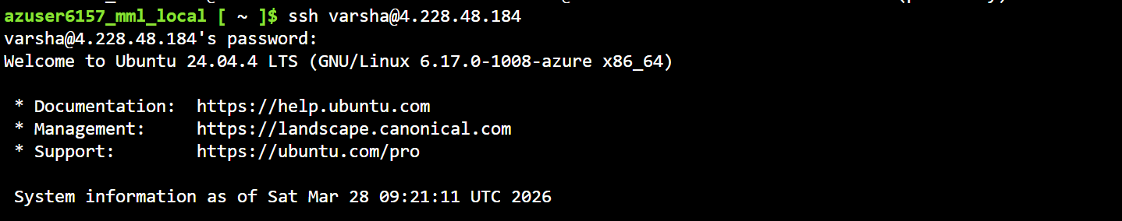
Step 2: Navigate to your website folder
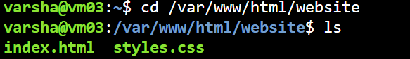
Ensure git is installed
sudo apt update
sudo apt install git -y
Step 3: Create crontab for auto update
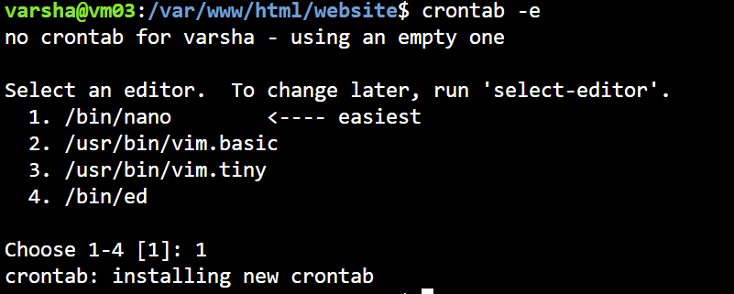
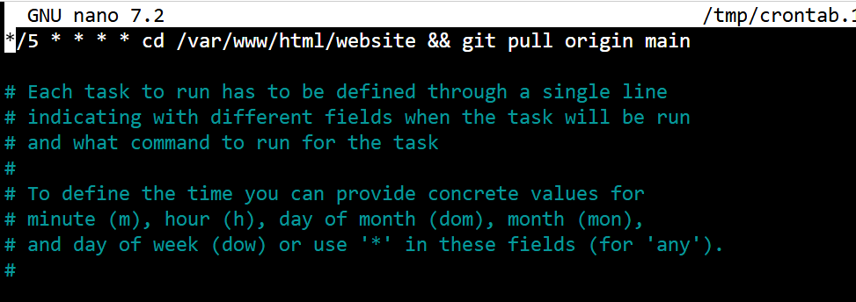
Step 4: Verify crontab registered
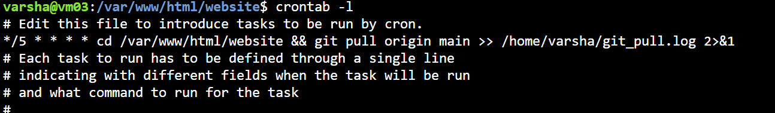
Step 5: Set ownership from root
Before:

After:


